PROJECT WORK CS6811
SECOND REVIEW

Federated Learning for Code Generation with Hallucination-Aware Fine Tuning

TEAM DETAILS
MENTOR
Dr. B. Thanasekhar,
Professor,
Computer Technology, MIT
Abhinavh P (2022503059),
Prabhakara Arjun R (2022503003),
Buvanes Srivardhan K (20225033037)

DOMAIN: Large Language Models

INTRODUCTION
Large Language Models (LLMs) have remarkable capabilities in code generation ,enabling automated solutions to a wide range of software engineering tasks. However LLMs frequently suffer from hallucinations in code generation, producing syntactically valid but semantically incorrect programs, non-existent APIs, or logically flawed implementations. Existing approaches to mitigating code hallucinations primarily rely on prompt engineering, repeated sampling, or full model fine-tuning. Full fine-tuning is computationally expensive and impractical in low-resource or decentralized settings, and repeated sampling does not address the underlying causes and mitigation of hallucination. In real-world development environments, code generation systems are often deployed across multiple decentralized clients where data cannot be centrally aggregated due to privacy, ownership.
To address these limitations we propose a hallucination-aware code generation framework that combines program analysis, targeted automatic program repair, and federated parameter-efficient fine-tuning using LoRA

PROBLEM STATEMENT
Code generation using large language models (LLMs) is currently hindered by hallucinations. Existing mitigation strategies typically rely on supervised fine-tuning or reinforcement learning from human feedback (RLHF), where models are trained to align with human preferences .While parameter-efficient fine-tuning methods such as LoRA reduce computational overhead compared to full fine-tuning, both approaches primarily optimize model behavior but without explicit verification of program correctness. As a result, these methods may improve correctness but often fail to systematically detect and correct deeper structural, semantic, and execution-level errors in generated code.
Furthermore, in real world scenarios, high-quality code and execution feedback are distributed across multiple organizations making centralized data collection infeasible due to privacy concerns. Without a secure and decentralized learning mechanism, models are unable to effectively learn from diverse hallucination patterns observed across clients. This creates a critical gap for a unified framework that integrates explicit hallucination detection and automated program verification with privacy-preserving, parameter-efficient adaptation to improve the quality of code generation .
OBJECTIVES
- To design a hallucination-aware code generation framework that integrates static and dynamic program analysis.
- To detect and classify different types of hallucinations in generated code.

- To apply automatic program repair for correcting hallucinated code using knowledge-guided patching.
- To fine-tune large language models using parameter-efficient LoRA in a federated learning setting.
- To evaluate the proposed framework on standard code generation benchmarks and analyze hallucination reduction.

LITERATURE SURVEY
S.NO | TITLE | NAME OF THE JOURNAL | METHODOLOGY | LIMITATIONS
[1] | Advancing LLM-Generated Code Reliability: A Hybrid Approach for Hallucination Detection | IEEE Transactions on Software Engineering (TSE), 2025 | - Proposes SDHD, a hybrid hallucination detection framework that integrates static analysis and dynamic execution for LLM-generated code.  .  - This framework detects eight hallucination types and achieves superior precision, recall, and F1-score across multiple benchmarks. | - Dynamic detection depends on test coverage quality, and incomplete coverage may miss certain logical failures.  .  - The framework is currently validated only on Python, limiting cross-language generalizability.
[2] | LLM-Based Test-Driven Interactive Code Generation: User Study and Empirical Evaluation | IEEE Transactions on Software Engineering (TSE), 2024 | - TICODER is a test-driven interactive workflow that incrementally clarifies user intent through LLM-generated tests and lightweight user feedback.  - The system ranks and prunes candidate code suggestions based on user-approved tests using two variants: PASS/FAIL validation and explicit output specification. | - There is interactive overhead, and incorrect or noisy user feedback can prune correct solutions prematurely.  - Effectiveness is contingent on the LLM's ability to generate high-quality tests.
[3] | A Federated Adaptive Large Language Model Fine-Tuning Framework for Software Development | IEEE Transactions on Services Computing, 2025 | - The framework integrates LoRA-based parameter-efficient fine-tuning within a federated setting, where each organization locally trains lightweight adapter modules and shares only adapter to the central server.  - A FedAvg-style is used to combine adapters based on local data size and an L2-norm constraint to manage gradient divergence | - Experimental results show degraded performance on unrelated datasets.  - Although communication costs are reduced, the framework still requires multiple communication rounds, which may introduce latency in large-scale federations.
[4] | Towards Efficient Fine-Tuning of Language Models With Organizational Data for Automated Software Review | IEEE Transactions on Software Engineering  2024 | - Proposes CodeMentor, a framework for few-shot learning that utilizes heuristic rules and weak supervision to construct datasets from internal organizational data  - It employs Low-Rank Adaptation (LoRA) for parameter-efficient fine-tuning and integrates Reinforcement Learning from Human Feedback (RLHF) to incorporate domain expertise. | - The framework depends on the quality of organizational data, which may introduce domain bias and limit generalization across different coding lang.  - RLHF requires computational resources and expert involvement,bottleneck scenario during scaling.
[5] | The Impact of Prompt Programming on Function-Level Code Generatio | IEEE Transactions on Software Engineering (TSE), 2025 | - Empirical study to evaluate the impact of prompt programming techniques on function-level code generation.  - CodePromptEval, a dataset of 7,072 prompts derived from 221 real-world Python functions, covering five prompt techniques: few-shot learning, chain-of-thought, persona, function signature, and package context, including all 32 possible combinations. | - The study is restricted to Python function-level tasks, limiting generalizability to other languages and higher-level program synthesis.  - Rely on benchmark-driven evaluation, which may not fully capture real-world scenario.  - Prompt techniques are evaluated in a fixed ordering, excluding effects of alternative prompt sequencing.
[6] | An Adaptive Framework Embedded With LLM for Knowledge Graph Construction | IEEE Transactions on Multimedia, Vol. 27, 2025 | - KG construction happens in three stages: Information Extraction (IE) for open triple extraction, Additional Relation (AR) for enriching triples with semantic information, and Knowledge Graph Normalization (KGN) for schema-level alignment using vector similarity search.  - Adaptive Prompt Generation (APG) module automatically generates, evaluates, and ranks prompts to guide LLM behavior across stages, enabling multi-domain KG construction from text, speech, and images. | - High computational overhead due to multi-stage LLM inference, embedding generation, and vector similarity matching.  - The framework relies heavily on prompt engineering, which,, is not fully autonomous and may still suffer from hallucination and semantic inconsistency.
[7] | Fight Fire With Fire: How Much Can We Trust ChatGPT on Source Code-Related Tasks? | IEEE Transactions on Software Engineering (TSE), Vol. 50, No. 12, 2024 | - Evaluating self-verification capability of GPT for: code generation, code completion, and program repair.  - Direct question, guiding question, and test report generation prompting is used assess whether ChatGPT can reliably validate its own outputs.  - Effectiveness is measured using accuracy, precision, recall, and F1-score, with additional analysis of self-contradictory hallucinations. | - Results show that ChatGPT frequently overestimates the correctness of its own outputs, leading to low recall in direct self-verification.  - While guiding questions and test reports improve recall, precision is reduced.  - Generated test reports often contain incorrect explanations, especially for code generation and failed repairs.  .  .
[8] | FedALoRA: Adaptive Local LoRA Aggregation for Personalized Federated Learning in LLM | IEEE Internet of Things Journal, Vol. 12, No. 24, December 2025 | - Proposes FedALoRA, a personalized federated learning framework that integrates LoRA-based PEFT with adaptive local aggregation to address severe non-IID data in federated LLM training.  - FedALoRA uses an Adaptive LoRA Aggregation to merge global and local parameters via locally learned weights. This selective, element-wise fusion focused on higher transformer layers preserves domain expertise while capturing shared knowledge without increasing communication costs. | - FedALoRA introduces additional local optimization complexity due to adaptive weight learning in ALoRA modules.  - The method requires careful tuning of the hyperparameter l, which controls the number of transformer layers involved in adaptive aggregation, and improper settings can degrade performance.
[9] | No Need to Lift a Finger Anymore? Assessing the Quality of Code Generation by ChatGPT | IEEE Transactions on Software Engineering (TSE), Vol. 50, No. 6, June 2024 | - Evaluation framework for assessing ChatGPT-based code generation. The authors construct standardized prompts for 728 LeetCode algorithm problems and 54 CWE security scenarios across five programming languages.  - Generated code is evaluated using automated judgment platforms (LeetCode for functional correctness) and static analysis tools (CodeQL for vulnerability detection).  - A multi-round fixing process is designed, where execution or analysis feedback is iteratively fed back | - ChatGPT performs significantly better on problems published before 2021, indicating reliance on memorized patterns rather than reasoning.  - The dialog-based fixing process has limited effectiveness, for logically complex problems .  - Generated code often contains security vulnerabilities and non-deterministic behavior.
[10] | Knowledge Enhanced Program Repair for Data Science Code | Proceedings of the 47th IEEE/ACM International Conference on Software Engineering (ICSE), 2025 | - API KG Construction is done using a custom ontology and RDF triples to model API attributes and dependencies for seven data science libraries.  - SPARQL is used for knowledge retrieval from on buggy code.  - AST level Bug Knowledge Enrichment, which executes code node-by-node to localize runtime and assertion errors at the AST node level. | - DS-KG is version-specific and requires continuous updates to track evolving API documentation, making long-term maintenance costly and error-prone.  - KG-based knowledge retrieval introduces higher latency than plain-text search
[11] | THINK: Tackling API Hallucinations in LLMs via Injecting Knowledge | IEEE International Conference on Software Analysis, Evolution and Reengineering (SANER), 2025 | - THINK proposes a two-phase API hallucination mitigation framework consisting of Pre and Post execution Optimization.  - Constructs an API knowledge database (Javadoc + validated code examples) and retrieves task-relevant APIs using task decomposition, similarity search, and LLM-based API labeling to guide code generation.  - Error Classification into Seven API Error Types for correction | - It may introduce irrelevant API knowledge, occasionally degrading performance for tasks already solvable by strong LLMs.  - Both retrieval results and ReAct-based repair depend on LLM generation, leading to non-deterministic behavior and reduced reproducibility across runs
[12] | EvoAPR: Enhancing Large Language Models for Automatic Program Repair with Genetic Algorithm and Dynamic LoRA | IEEE International Conference on Web Services (ICWS), 2025 | - Genetic evolution of buggy hunks under tri-objective fitness: syntax compliance, bug-hunk masking rate, repair-location masking rate.  - Dynamic LoRA swaps non-overlapping rank-r adapters per bug-index/project for on-demand, project-specific parameter retrieval.  - Base + LoRA models generate candidate patches; token-level entropy scorer picks the least uncertain fix as the final patch. | - Genetic template evolution and dynamic LoRA fine-tuning introduce significant computation and implementation complexity compared to direct prompting-based APR methods.  - The effectiveness of both stages relies on accurate bug localization and rich bug context.
[13] | CodeHalu: Investigating Code Hallucinations in LLMs via Execution Based Verification | Proceedings of the AAAI Conference on Artificial Intelligence (AAAI), 2025 | - Executes LLM-generated code against test cases under time and memory constraints, recording execution failures, unexpected outputs, infinite loop behaviors to detect hallucination states.  - Aggregates execution states across multiple LLMs and applies a two-stage heuristic induction process to classify hallucinations into four main types (Mapping, Naming, Resource, Logic) and eight subcategories. | - The study focuses exclusively on Python, and hallucination behaviors in other programming languages are not evaluated.  - CodeHalu targets functional and logical correctness; identifying or mitigating security vulnerabilities is outside its scope.

ARCHITECTURE DIAGRAM OF THE PROPOSED SYSTEM
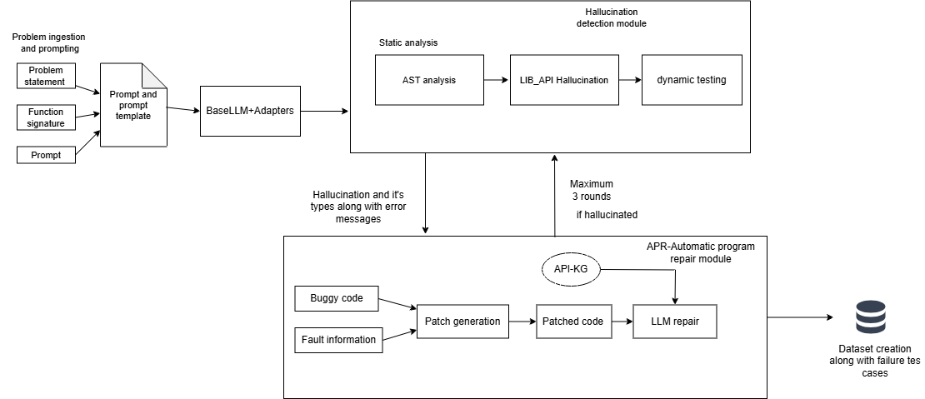
Fig1. Client side hallucination detection and mitigation framework

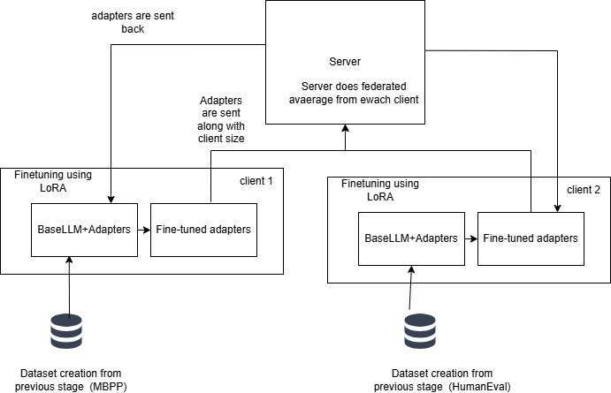
Fig 2. Federated learning + LoRA for fine-tuning

IDENTIFICATION OF PROJECT MODULES, TOOLS & PLATFORMS
S.NO | MODULES | SUB - MODULES | TOOLS & PLATFORMS
1. | Problem ingestion and code generation | - Dataset selection .  - Client-wise dataset partitioning .  - Single-shot prompting.  - Pretrained LLM selection and loading.  - Baseline inference using frozen LLM | Hugging Face Datasets, Transformers, Python, Pandas, NumPy, Google Colab.
2. | Base Model Selection and Configuration | - Static analysis using AST ,Library analysis.  - Structured hallucination labeling. | Python ast module
3. | Automatic Program Repair (APR) | - Knowledge extraction.  - Patch-based repair  - Bounded repair attempts.  - Ground-truth verification and hard hallucination labeling. | Numpy ,pandas, sklearn , scipy, statsmodel , Qwen2.5-Coder (Repair), Python.
4. | Fine tuning using LoRA | - Hallucination-aware dataset construction  - Low-rank decomposition (r = 8).  - Injection of LoRA modules into Query and Key projections.  - Parameter isolation with frozen backbone.  - Adapter checkpointing. | PyTorch, Hugging Face PEFT, Transformers.
5. | Federated Aggregation and Distribution | - Secure client-side adapters  - Federated Averaging (FedAvg) with sample-size-based weighting.  - Global adapter construction | Flower ,PyTorch, NumPy
6. | Evaluation and analysis | - Evaluation on MBPP, HumanEval, and DS-1000 benchmarks.  - Functional correctness using Pass@1.  - Hallucination detection metrics (Precision, Recall, F1).  - Code similarity analysis using CodeBLEU.  - Cross-client validation.  - Before–after performance comparison. | CodeBLEU, Matplotlib, Seaborn, Scikit-learn

METHODS / MODELS
1. Problem ingestion and code generation
Input:
Benchmark code-generation datasets.
Output:
Initial LLM-generated code solutions (potentially containing hallucinations).
Methods:
- Dataset Loading: Benchmark code-generation datasets including MBPP, HumanEval, and DS-1000 are loaded using the Hugging Face library.
- Client-wise Dataset Allocation: Each federated client is assigned a distinct dataset or dataset subset to simulate heterogeneous behaviour.
- Problem Specification Construction: For each task, structured inputs consisting of the problem statement, function signature, constraints is constructed.
- Single-Shot Prompting: Code generation is performed using a single-shot prompting strategy, where the model receives the task specification without iterative refinement.
- Baseline Inference: The frozen Qwen2.5-Coder-3B pretrained model is used to generate initial code outputs, which may contain hallucinations and serve as baseline for downstream analysis.

2. Hallucination detection
Input:
LLM-generated code obtained from the code generation module.
Output:
Detected hallucination types along with structured diagnostic information.
Methods:
- AST Construction and Analysis: Abstract Syntax Tree (AST) is constructed and analyzed to detect syntax errors, undefined variables, and invalid language constructs.
- Library analysis: We use ast to check if each methods,functions align with the library in static setup.
- Dynamic Analysis: The test cases are executed on the code to detect runtime errors and semantic hallucinations.
- Hallucination Labeling: Detected errors are categorized into different hallucination types, and the resulting information is recorded for dataset construction during fine-tuning.

3. Automatic program repair module
Input:
Buggy code, detected hallucination type, fault hints, and a domain knowledge graph suggestions.
Output:
Corrected code validated against ground-truth oracles or hard hallucination label.
Methods:
- Knowledge Extraction: library, class, method, and dependency information is extracted from dir,help,inspect .
- Patch-Based Repair: Applying localized patches to the hallucinated code from fault information from previous modules.
- Fault-Guided Prompting: The detected hallucination type, fault hints, and relevant knowledge graph entries are provided to LLM for code correction.
- Bounded Repair Attempts : program repair is performed with a bounded number of attempts to ensure controlled behavior.
- GT Verification: Each candidate is then verified with Hallucination detection module. If verification fails after bounded attempts,it is marked as hard hallucination.

4. Fine tuning using LoRA
Input:
Hallucination-aware code samples, including buggy code, diagnostic information, and repair outcomes, along with a frozen pre-trained LLM.
Output:
Client-specific LoRA adapters trained on hallucination aware datasets.
Methods:
- Dataset Construction: Construct structured dataset using problem description, buggy code, hallucination type, repairability flag and corrected code.
- Low-Rank Decomposition: Weight updates are parameterized using two low-rank matrices A and B, where the rank r is set to 8.
- Attention Layer Injection: LoRA modules are injected into the Query and Key projection matrices of each Transformer layer.
- Parameter Isolation: Original model weights remain frozen, and only LoRA parameters are made trainable.
- Adapter Checkpointing:Only trained LoRA adapter weights are saved and transmitted to the server, ensuring lightweight communication and privacy preservation.

5. Federated Aggregation and Distribution
Input:
Client-side LoRA adapter weights, along with sample size.
Output:
Global LoRA adapter distributed to all participating clients.
Methods:
- Adapter Collection: LoRA adapter weights are collected from all participating clients after local fine-tuning.
- Federated Averaging: Client-side adapters are aggregated using the Federated Averaging (FedAvg) algorithm, where clients with larger sample sizes contribute proportionally higher weights to the global adapter.
- Global Adapter Construction: A global LoRA adapter is constructed by averaging the weighted client adapters while keeping the base model parameters frozen.
- Adapter Distribution: The aggregated global LoRA adapter is redistributed to all clients and combined with the shared base model for subsequent inference or further training rounds.

6. Evaluation and analysis
Input:
Code generated by the base model and the federated LoRA-enhanced model across benchmark datasets.
Output:
Benchmark-wise evaluation.

Methods:
- Functional Correctness (Pass@1):The Pass@1 metric is used to measure functional correctness if code passes all unit tests on the first attempt.
- Hallucination Detection Metrics: Precision, Recall, and F1-score are computed based on oracle-validated hallucination labels to assess the accuracy of hallucination detection.
- Code Similarity Analysis: CodeBLEU is used as a secondary metric to measure syntactic and structural similarity between generated code and reference implementations.
- Cross-Client Validation: Cross-validation is performed across federated clients to evaluate generalization and robustness under heterogeneous data distributions.
- Before–After Comparison:Model performance is compared before and after LoRA fine-tuning to quantify improvements in correctness and hallucination reduction.

IMPLEMENTATIONRESULTS

MODULE 1
Figure 3,4,5 shows the data loading for three dataset HumanEval, MBPP and DS1000 respectively.
Figure 6 shows the code snippet for code generation with QwenCoder template, which involves tokenization, decoding and code extraction.
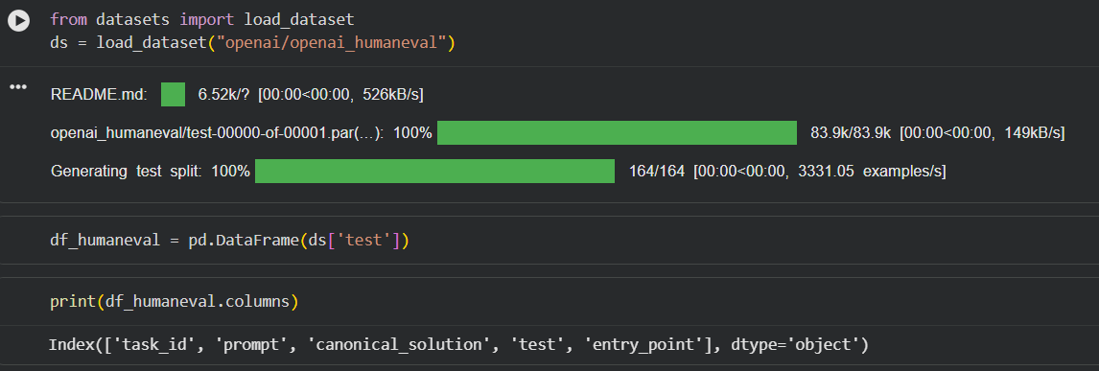
Fig 3

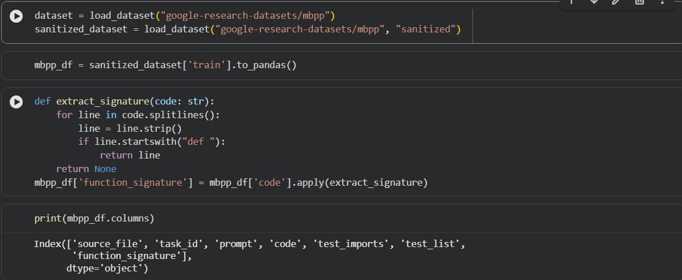
Fig 4

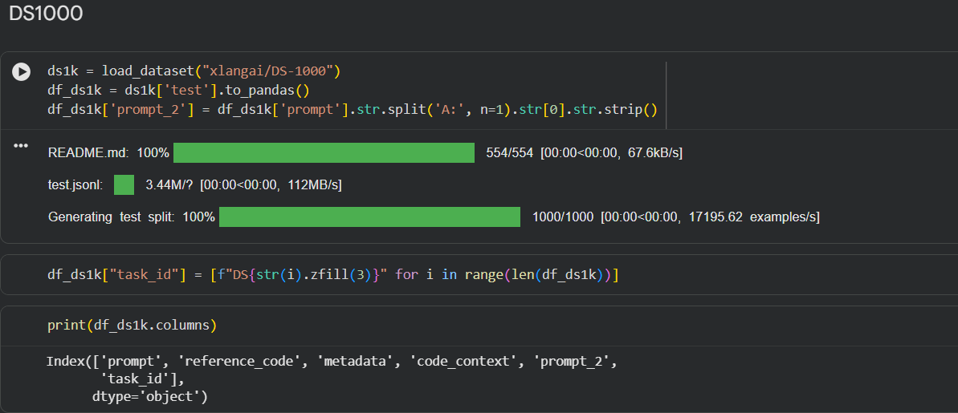
Fig 5

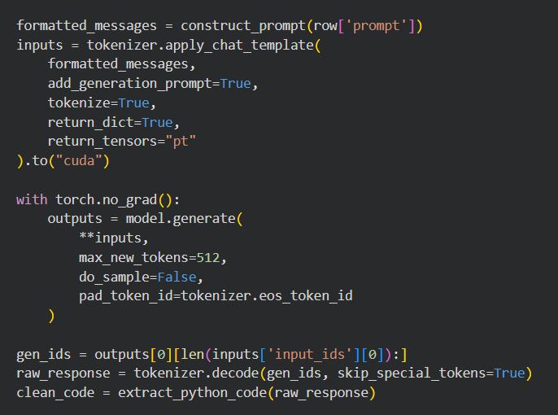
Fig 6
MODULE 2
Figure 7 shows hallucination distribution across all 3 datasets classified into syntax, indentation errors, structural hallucinations.
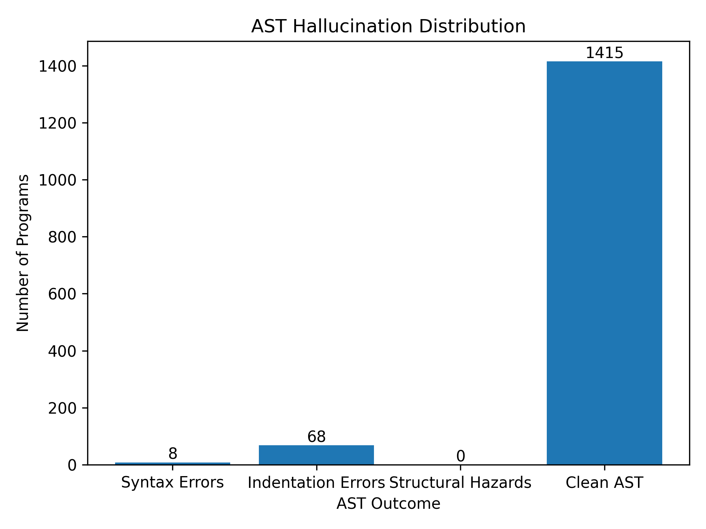
Fig 7
Figure 8 shows library or api hallucination across all dataset.
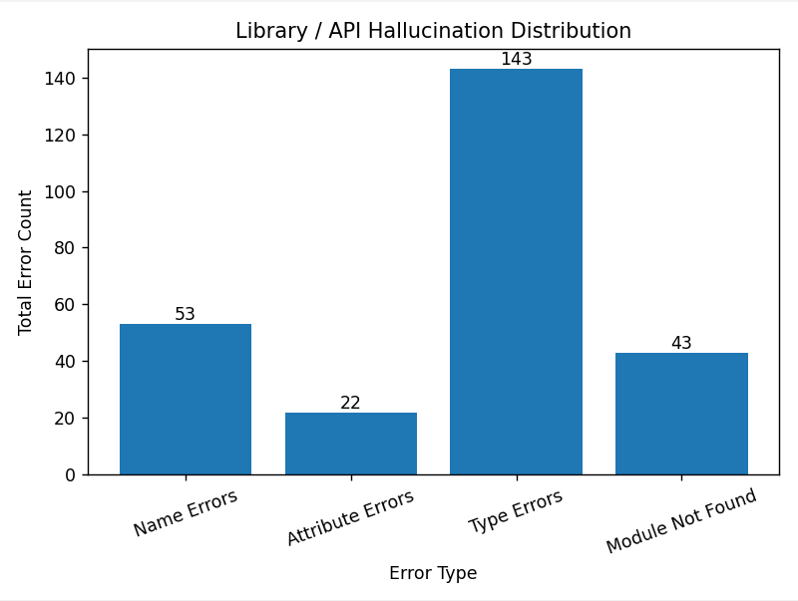
Fig 8
Figure 9 & 10 shows results after dynamic hallucination. Fig 9 describes the different type of errors encountered in a dataset. Fig 10 gives the overall hallucination pass and fail after dynamic analysis.

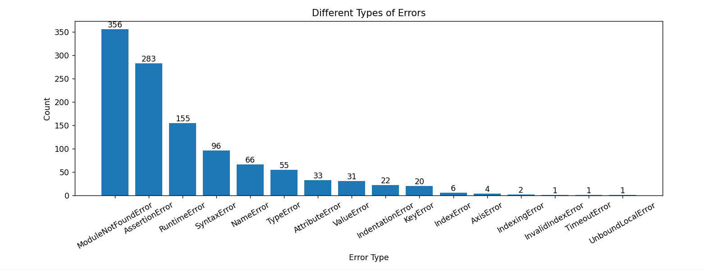
Fig 9
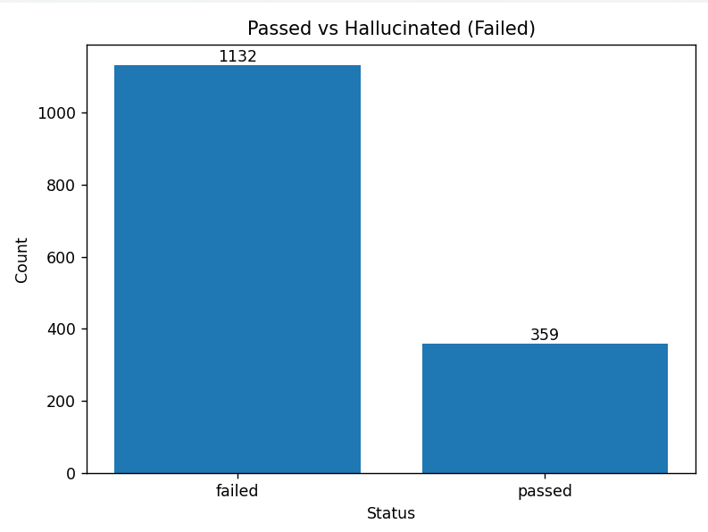
Fig 10
MODULE 3
Figure 11,12,13 shows an example from DS100 with task_id 42. We could see the patch generated around the error line and also the information to fix the error from fault_information.
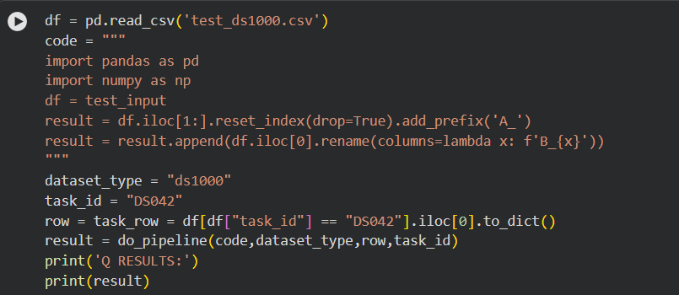
Fig 11
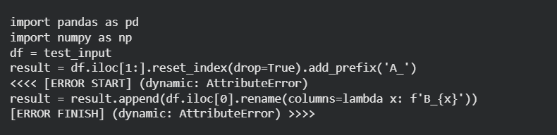
Fig 12
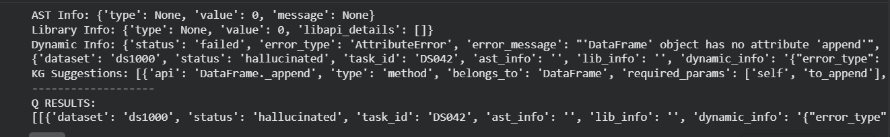
Figure 13
EXPERIMENTAL SETUP
- Base LLM :
  - QwenCoder2.5-3B parameter is used as base model.
  - Type: Causal Language Models
  - Training Stage: Pretraining & Post-training
  - Number of Parameters: 3.09B
  - Number of Paramaters (Non-Embedding): 2.77B
  - Number of Layers: 36
  - Number of Attention Heads (GQA): 16 for Q and 2 for KV
  - Context Length: Full 32,768 tokens
  - 4-bit Quantized Model Loading:The model was loaded using 4-bit quantization with the bitsandbytes library.
  - Deterministic Generation Settings: We configured do_sample = False and temperature = 1.0 to ensure deterministic and reproducible code generation across multiple runs.
- Dataset:
  - HumanEval: Consist of 164 rows and 5 features.
  - MBPP: Consist of 377 rows and 6 features. It is made up of most basic python programming.
  - DS1000: Consist of 1000 data science problems in python.
- Development environment:
  - Google collab: It is used for LLM inference, code generation ,building overall pipeline.It used NVIDIA T4 GPU with CUDA acceleration on runtime.
  - VS Code: Local system is used to build static and dynamic modules which doesn’t require GPU computation. Building modules and analysis is done on local from the generated dataset.

EVALUATION METRIC

Pass@1: The Pass@1 metric is used to measure functional correctness if code passes all unit tests on the first attempt.
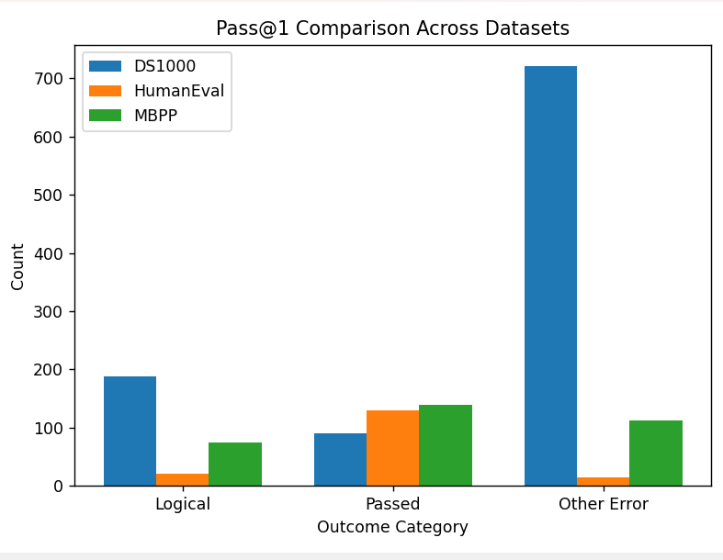
Pass@1 comparison across dataset.

TIMELINE FOR COMPLETION OF MODULES
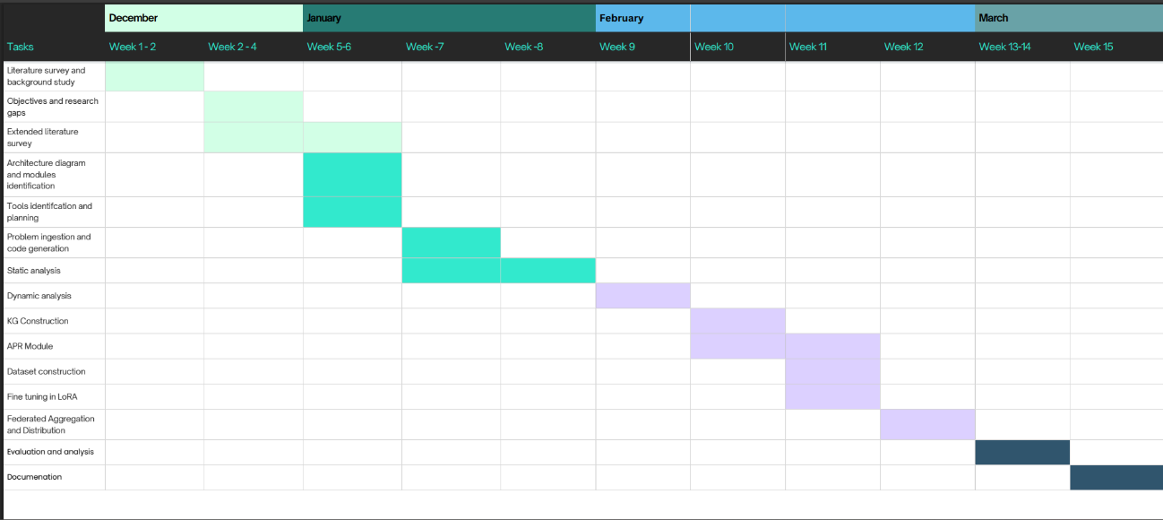

REFERENCES
[1] B. Yang, J. Dang, H. Liu and Z. Jin, "Advancing LLM-Generated Code Reliability: A Hybrid Approach for Hallucination Detection" in IEEE Transactions on Software Engineering, vol. , no. 01, pp. 1-17, PrePrints 5555, doi: 10.1109/TSE.2025.3640641.
[2] S. Fakhoury, A. Naik, G. Sakkas, S. Chakraborty and S. K. Lahiri, "LLM-Based Test-Driven Interactive Code Generation: User Study and Empirical Evaluation," in IEEE Transactions on Software Engineering, vol. 50, no. 9, pp. 2254-2268, Sept. 2024, doi: 10.1109/TSE.2024.3428972.
[3] J. Chen, Z. Cai, W. Chen, W. Wang, Z. Zheng and P. S. Yu, "A Federated Adaptive Large Language Model Fine-Tuning Framework for Software Development," in IEEE Transactions on Services Computing, doi: 10.1109/TSC.2025.3623626
[4] M. Nashaat and J. Miller, "Towards Efficient Fine-Tuning of Language Models With Organizational Data for Automated Software Review," in IEEE Transactions on Software Engineering, vol. 50, no. 9, pp. 2240-2253, Sept. 2024, doi: 10.1109/TSE.2024.3428324
[5] R. Khojah, F. G. de Oliveira Neto, M. Mohamad and P. Leitner, "The Impact of Prompt Programming on Function-Level Code Generation," in IEEE Transactions on Software Engineering, vol. 51, no. 8, pp. 2381-2395, Aug. 2025, doi: 10.1109/TSE.2025.3587794
[6] Q. Wang, C. Li, Y. Liu, Q. Zhu, J. Song and T. Shen, "An Adaptive Framework Embedded With LLM for Knowledge Graph Construction," in IEEE Transactions on Multimedia, vol. 27, pp. 2912-2923, 2025, doi: 10.1109/TMM.2025.3557717
[7] X. Yu, L. Liu, X. Hu, J. W. Keung, J. Liu and X. Xia, "Fight Fire With Fire: How Much Can We Trust ChatGPT on Source Code-Related Tasks?," in IEEE Transactions on Software Engineering, vol. 50, no. 12, pp. 3435-3453, Dec. 2024, doi: 10.1109/TSE.2024.3492204
[8] X. Yi, C. Hu, B. Cai, H. Huang, Y. Chen and K. Wang, "FedALoRA: Adaptive Local LoRA Aggregation for Personalized Federated Learning in LLM," in IEEE Internet of Things Journal, vol. 12, no. 24, pp. 51854-51865, 15 Dec.15, 2025, doi: 10.1109/JIOT.2025.3582427
[9] Z. Liu, Y. Tang, X. Luo, Y. Zhou and L. F. Zhang, "No Need to Lift a Finger Anymore? Assessing the Quality of Code Generation by ChatGPT," in IEEE Transactions on Software Engineering, vol. 50, no. 6, pp. 1548-1584, June 2024, doi: 10.1109/TSE.2024.3392499
[10] S. Ouyang, J. M. Zhang, Z. Sun and A. M. Penuela, "Knowledge-Enhanced Program Repair for Data Science Code," in 2025 IEEE/ACM 47th International Conference on Software Engineering (ICSE), Ottawa, ON, Canada, 2025, pp. 898-910, doi: 10.1109/ICSE55347.2025.00246.
[11] J. Liu, Y. Zhang, D. Wang, Y. Li and W. Dong, "THINK: Tackling API Hallucinations in LLMs via Injecting Knowledge," 2025 IEEE International Conference on Software Analysis, Evolution and Reengineering (SANER), Montreal, QC, Canada, 2025, pp. 229-240, doi: 10.1109/SANER64311.2025.00029.

[12] H. Zhang, Q. Yan, W. Min, C. Zhang, L. Kuang and Y. Xia, "EvoAPR: Enhancing Large Language Models for Automatic Program Repair with Genetic Algorithm and Dynamic LoRA," 2025 IEEE International Conference on Web Services (ICWS), Helsinki, Finland, 2025, pp. 946-956, doi: 10.1109/ICWS67624.2025.00123.

[13] X. Yi, C. Hu, B. Cai, H. Huang, Y. Chen and K. Wang, "FedALoRA: Adaptive Local LoRA Aggregation for Personalized Federated Learning in LLM," in IEEE Internet of Things Journal, vol. 12, no. 24, pp. 51854-51865, 15 Dec.15, 2025, doi: 10.1109/JIOT.2025.3582427

